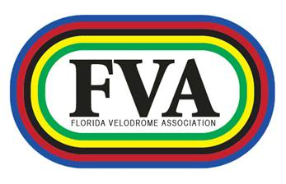
2012 Fastest Mile Results
Sept 15, 2012

Elite Women:
1 Crystal Little 2:29.57
2 Amy Good 2:34.60
3 Lisa Schneidr 2:36.38
4 Merdith Sauls 2:54.60

Non-licensed Women:
1 Isabel Olivas 2:25.71
2 Kim Hack 2:33.89
3 Alejandra Paredes 2:52.89
4 Cristina Ribeiro 3:17.33

35+
1 Esteban Arniella 2:02.28
2 Shannon Malmquist 2:07.66
3 Steven Mlujeak 2:08.03
4 Roman Morozov 2:10.10
5 Dan Valdes 2:24.46
6 Carlos Cruz 2:30.13

45+
1 Peter Davis 2:10.00
2 George Luft 2:27.29

Elite Men
1 Alex Gil 1:57.25 Track record.
2 Lucas Wardien 1:59.36
3 David Espinoza 2:01.49
4 Jake Silverberg 2:02.50
5 Grant Potter 2:02.91
6 KC Boutiette 2:04.66
7 Frank Frederick 2:05.44
8 Jose Frank Rodriguez 2:06.04
9 Michael Cedeno 2:09.81
10 Sean Kenney 2:14.65
11 John Gilbert 2:18.87
12 Adrian Enriquez 2:19.54
13 Jorge Jaile 2:23.41
14 Jake Gilmore 2:25.44

Non-licensed Men
1 Christian Klugmann 2:17.99
2 Alex Vilar 2:22.16
3 Santiago Campos 2:25.11
4 Markku Biedermann 2:30.72
5 Po Yu Lin 2:40.67

